Task 2 MULEARN X OWASP
Date : 19/07/2025
Author: Sunny Abraham Mathew
Step 1 :
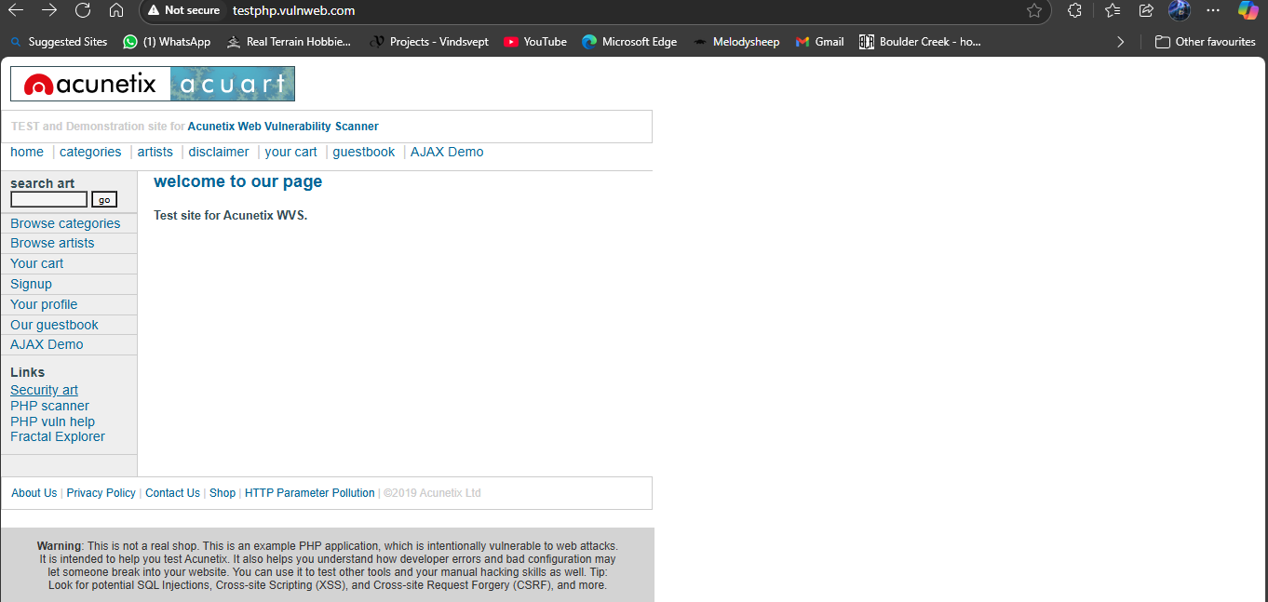
I Took http://testphp.vulnweb.com which was made vulnerable for testing.
Step 2:
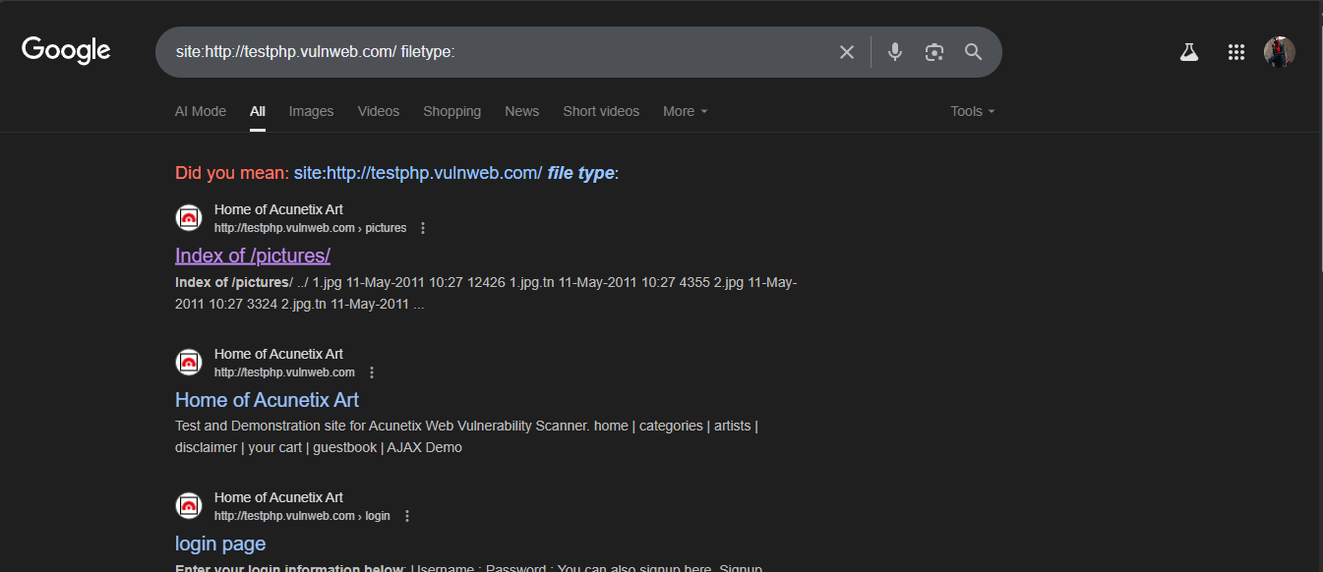
I found hidden pages using dorking.

Step3: 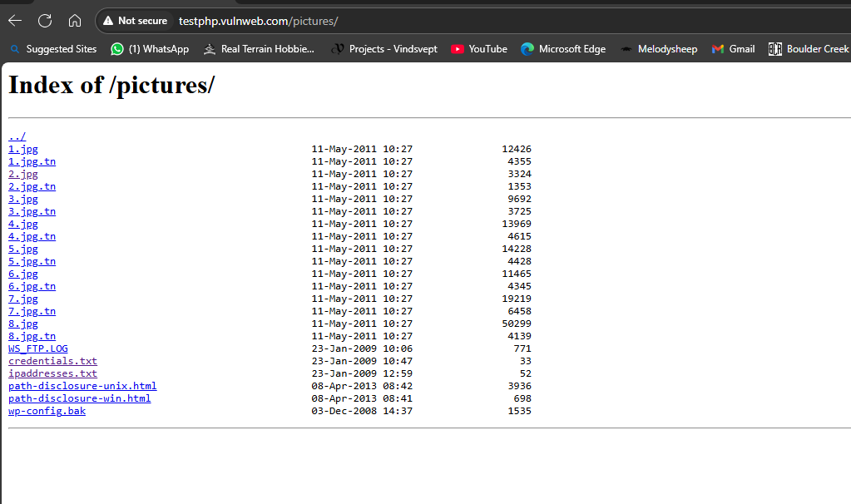
Founded hidden documents like credentials.txt and ipaddresses.txt

